# *Welcome to CVIPtools from SIUE*

### *A software package for the exploration of computer vision and image processing*

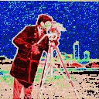

### *Introduction*

CVIPtools is a Windows based software package developed at the [Computer Vision and Image Processing Laboratory](http://www.ee.siue.edu/CVIPtools/CVIPlab.html) here at [Southern Illinois University at Edwardsville](http://www.siue.edu/), under the continuing direction of Dr. Scott E Umbaugh**.** One of the primary purposes of the CVIPtools development is to allow students, faculty, and other researchers to explore the power of computer processing of digital images.

CVIPtools is a collection of computer imaging tools providing services to the users at four layers: the C function layer, the COM interface layer, the CVIPImage layer and the Graphical User Interface (GUI). The C function layer consists of all image and data processing procedures and functions. The Common Object Module (COM) interface layer implements the COM interface for each higher level CVIPtools function, primarily the Toolbox functions with a few Toolkit functions. The CVIPImage layer encapsulates the COM interface functions and provides an Object Oriented Programming (OOP) approach. The GUI implements the image queue and manages user input and resultant output. The CVIPtools GUI allows even the casual computer users to experiment with many of the sophisticated tools available to computer imaging specialists without the need for any knowledge of computer programming.

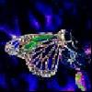  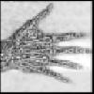  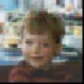

Edge Detection Image Segmentation Local Hisogram Eq. Image Warping Block Trunc. Coding